Peer-learning implemented in THP: what to expect?

1. Introduction

The Hacking Project is a course that will make you think differently and learn in a different way. Ok that's cool! But what exactly is it about? Before we start, let me explain our mindset.

2. The resource

2.1. The "learning by doing" methodology
The Hacking Project believes in one thing: you learn by doing. Instead of giving you lectures where you won't even remember half of the information, we prefer to let you look for the information yourself and learn by doing, through long projects. We have noticed that with the rise of smartphones and knowledge available in two clicks on Google, the people who will succeed in the technological revolution will be those who know how to find the right information at the right time, rather than those who memorize the lessons given.

The Hacking Project's pedagogy is exactly that. By giving you few classes and a focus on projects, you will be forced to spend time searching the web, then comparing different theories to choose the one that best suits your needs. So, rather than just asking you to do a SWOT, you will have to think outside the box to discover the best marketing method. You will have to find the answers to your questions yourself. Obviously, at first it feels weird... But after a few days, it will come naturally. And believe me, this skill will serve you for the rest of your life. It will help you to question many things, and above all, not to be a sheep.

⚠️ COMMON MISTAKE
Be careful! Keep this information in mind as it will be used throughout the THP course and is one of the main reasons why people give up.
The Hacking Project is project-based learning school. As such, it is strongly discouraged to spend more than 20 minutes on a resource before tackling the day's project. Go through the resource to see what it is about, do the projects, and use the supporting resources to complete the project. Understanding new concepts without getting your hands dirty is much harder than understanding by reading. I see a lot of people who "want to understand well before moving on to the project of the day" thinking they are doing well because traditional school taught them that. Of these people, never one finished THP, and I'm not kidding.

The goal is not to rush into the project without understanding anything, but to understand that the resource has concepts that will help you in the project, and that by doing so, you will understand it much better. All the notions learned by heart, this method does this and that, is delegated to Google which is much stronger than you for memorization. The added value of a modern worker is the use of the information given by Google to make complex projects.

So if you ever see someone who is still trying to "get the resource of the day right" when it's the middle of the day, give them that resource and tell them they'll understand it much better by doing a concrete project than by trying to reread an abstract concept for the umpteenth time. Really, this person's success or failure depends on it.

2.2. Peer learning methodology
The Hacking Project has another maxim: "you learn by teaching". Noting that the best French code schools rely on not having a teacher (42, Epitech), we deduced that :
- Being in a group with other students allows you to explain difficult concepts to each other in your own words. The learning process is done in groups, just like in the work world.
- Not having a teacher to give you the solution teaches you humility: not only you know that what you are doing can be improved, but you will also realize that the perfect solution does not exist.

At The Hacking Project, it won't be easy. We purposely give you complicated projects so that you do them together, as a group, as a community. You can get discouraged quickly by the difficulty of the exercises, but it's so that you do the projects together, and stick together. If you ever get discouraged, know that other members are in the same boat and together you will succeed.

2.3. Search, and find the information
The Hacking Project is a program that will teach you a fundamental notion of a 21st century office worker: "you don't necessarily have to know the information, but you have to know where to find it".
Thus, it is not possible to carry out the projects without the help of the Internet, and additional research. The Internet will be used to deepen your knowledge, to unblock you, to bring you bonus notions, and many others. During the training, we will give you incomplete resources, sometimes voluntarily, to encourage you to leave your comfort zone and search for information by yourself, and to share it with others. Why? Simply because that's how it works in real life, so you might as well take the plunge directly 😃
Most courses hand you the solutions on a silver plate as soon as you get stuck for more than 10 seconds (I'm not exaggerating), which means that when you leave, you'll only be good at stupidly applying code without having any autonomy.
So yes, this technique takes you out of your comfort zone, but look at the huge benefit to this: you will have acquired a second nature that will make you self-sufficient, curious, knowledge-seeking, and resourceful people. Who doesn't want to work with these people 😉

2.4. Seek and find help
We're not going to hide it from you: you'll get stuck. More than once. Being stuck is part of the learning process and part of life. It's part of being a person to find solutions to problems, whether they're personal, professional, or about code that doesn't work. Fortunately, finding help is possible. Usually on the internet, or in the community.

Here is a short guide to ask for help from the community.

2.4.1. Read errors
Very often, the computer helps us to understand the errors. Here is an example made with Ruby, a programming language :
a = 1
b = "1"
print a + b

=> `TypeError: no implicit conversion of Fixnum into String`

Here, we can see that the computer can't convert an integer into a string. We can also see that it is a correspondence issue: we wanted to add a string and an integer together, which makes the code bugs...

2.4.2. Search on Google
I use Google every 10 minutes when I code. Sometimes, it's because I forgot: ‘how to add an element in array ruby’. Other times, it's to fix bugs. To take the code above, if I copy and paste this error in Google, I would get lot of similar cases where people wanted to add strings to integers, as well as the solutions they found.

2.4.3. Ask for help!
Sometimes you get really stuck. It doesn't matter: you can ask your group mates for help, or ask in the Discord! Here are a few tips on how to ask your questions, which will help you not to get stuck:
⚠️ COMMON MISTAKE
Sometimes I see mates asking for help with a nice message like :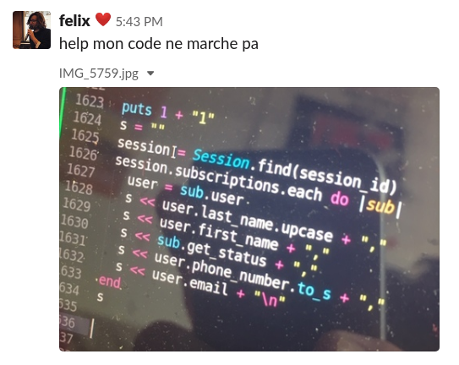
I don't know about you, but when I see messages like this, it makes me absolutely not want to take 5 minutes to help the person. Here are the main mistakes that have been made:
- No context: I don't know what "it doesn't work" means. Does the program crash? Does it not give the desired result? Without knowing the context, we don't know how to help. Personally, I don't have anything else to do than to take all his code to test it at home and understand why "it doesn't work".
- The person does not tell us what he/she have done or tried as solutions. Often, the answers are "have you tried X or Y?". It's hard to guess how to get him/her out of trouble without a minimum of details, isn't it?
- A picture: most people will copy and paste the error into Google and see with you how to help. If you provide them with a screenshot -- or worse, a picture of your screen (I swear it happens, and it's not that rare)! -- people won't be able to copy and paste, and will tell you to go to hell.

Let's look at how to ask a good question to get help.

2.4.3.1. Structure of a good question
- Start by saying what you want to do.
  - Context is very important: What do you want to do with this program? Why doesn't the program respond the way you want it to?
- Specify what you have searched so far.
  - Since we are going to take time to help you, it is important to know that you also took time to search and that we are not going to simply copy and paste the error and give you the first Google result as a solution.
- Give the code that does not work.
  - It's hard to help you without it. For the code, we advise you to put it between ```` as shown here. For larger pieces of code, we recommend creating snippets.
- Give the error that the program returns you
  - 90% of the time, the answer is in the error. So it would be a shame not to provide it too... As for the code snippets, we advise to put everything in the right format (with ``` or snippets).

2.4.3.2. Example of a well asked question
Here's an example of a well-asked question on Slack. If you follow this structure, everything should be fine :)
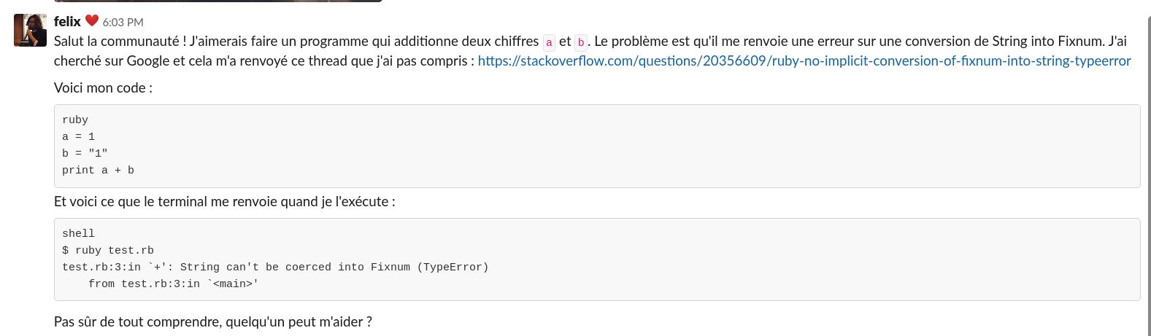

3. To recap

Peer learning may hurt your brain at first. But hang in there, because it's definitely worth it!

